Morgan Bronson

February 18, 2022

Technical Report Yellowstone Map

Introduction:

Coordinate systems have been in use for decades, centuries even, and they are becoming increasingly important as we rely more on technology to create maps and use these coordinate systems. We’ve learned this week the importance of making sure coordinate systems and map projections are correct on our own maps to ensure the validity and reliability of the data we present. This week, we are using data from the Yellowstone database to do some map projections.

Data Used:

|  |  |  |
| --- | --- | --- |
| Data Name | Current Coordinate System | What tool used and why |
| bisonwtr | Unknown | Define Projection; the SRS is missing |
| fire_perim | NAD 1983 UTM Zone 12N | No tool; coordinate system is correct |
| Region_DEM | GCS_North_American_1983 | Raster Projection; the coordinate system is not correct and is raster data |
| yell_facilities | Unknown | Define Projection & Project; the SRS was missing, but we knew the data was collected in WGS 1984, so I had to define the coordinate system to that first, and then used the project tool to convert the coordinate system to NAD 1983 UTM Zone 12N |
| yellowstone_fire_starts | Unknown | Define Projection & Project; the SRS was missing, but we knew the data was collected in WGS 1984, so I had to define the coordinate system to that first, and then used the project tool to convert the coordinate system to NAD 1983 UTM Zone 12N |
| YNP_boundary | NAD 1927 UTM Zone 12N | Project; the SRS is there, but it’s wrong and is vector data |
| YS_Roads27 | NAD 1927 UTM Zone 12N | Project; the SRS is there, but it’s wrong and is vector data |
| YS_Roads83 | NAD 1983 UTM Zone 12N | No tool; coordinate system is correct |

Methods:

Bison- the spatial reference coordinate system was missing, so that’s why the feature class was displaying where it did. Using the define projection tool allowed me to change the SRS to a different coordinate system.

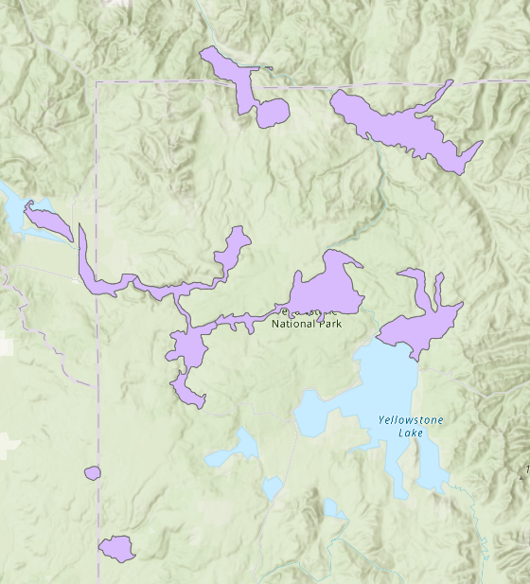

YND Boundary (NAD 1983 & NAD 1927 layers)

Plate Caree, N is up

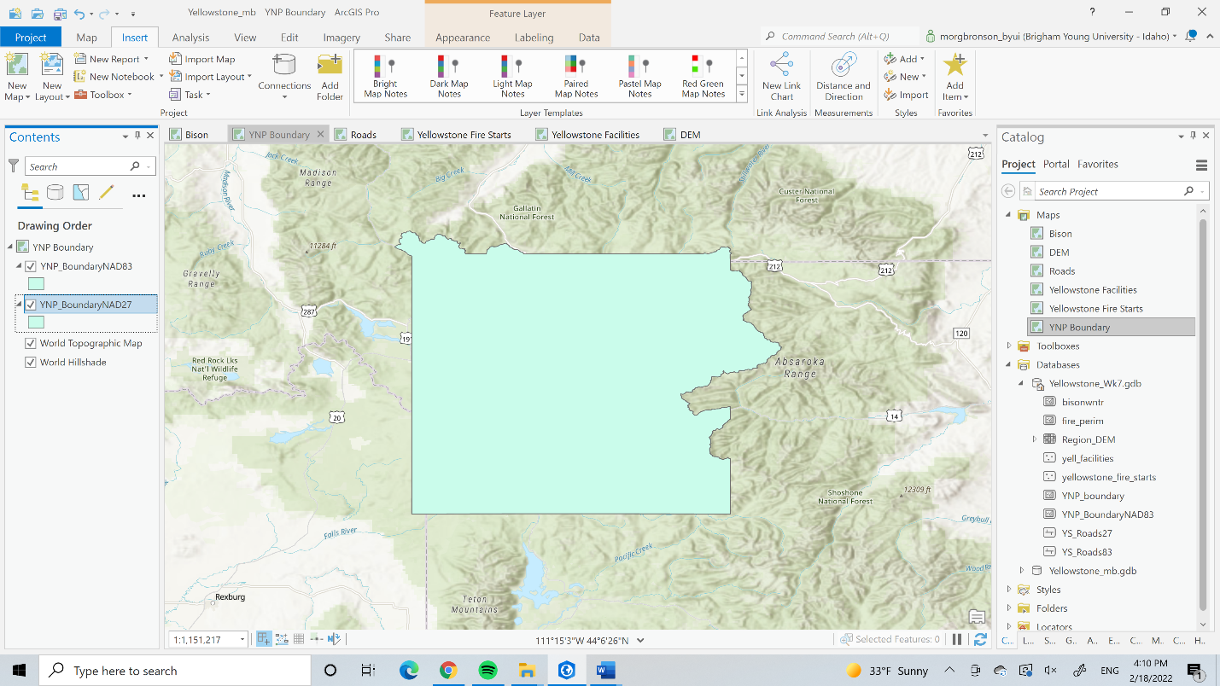

Equidistant Conic (world), N is right

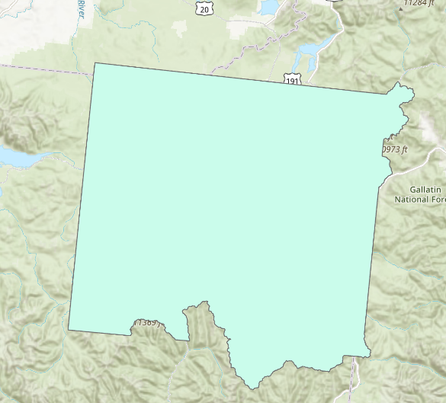

Equidistant Conic, N is up a little to the right

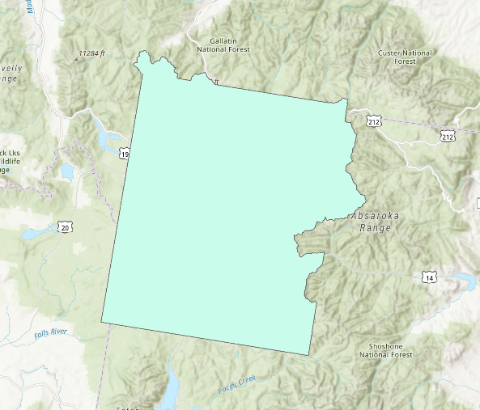

WGS 1984 UTM Zone 12N, N is up

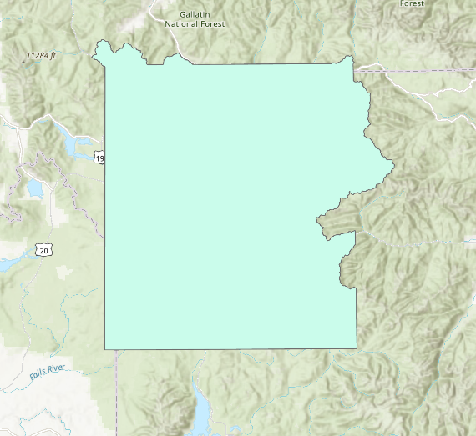

Roads:

The NAD 1983 road layer lines up with the basemap better than the NAD 1927 layer does. For this reason, I believe the 1983 road layer is more correct.

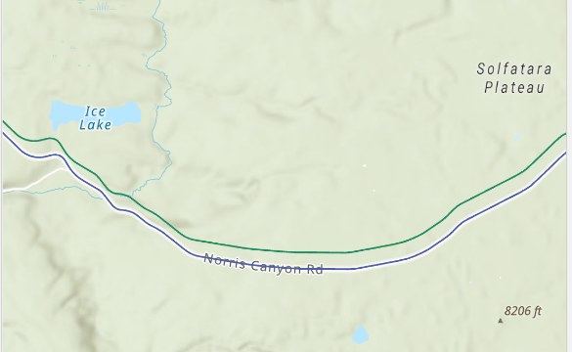

Fire Starts:

First I used the define projection tool to get the feature class to use the WGS 1984 coordinate system, and then I used the project tool to switch the coordinate system to NAD 1983 UTM Zone 12N.

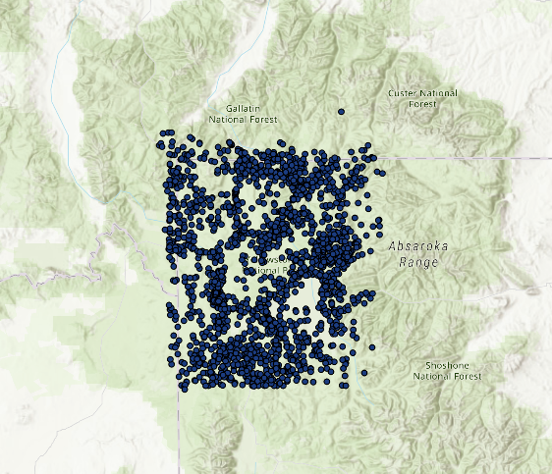

Facilities:

When I put the Yellowstone Facilities layer onto the map, I had the same issue that I did with the Fire Starts layer (that the points were not where they were supposed to be), so I repeated the same process as above: define projection to WGS 1984 and then project to NAD 1983 UTM Zone 12N.

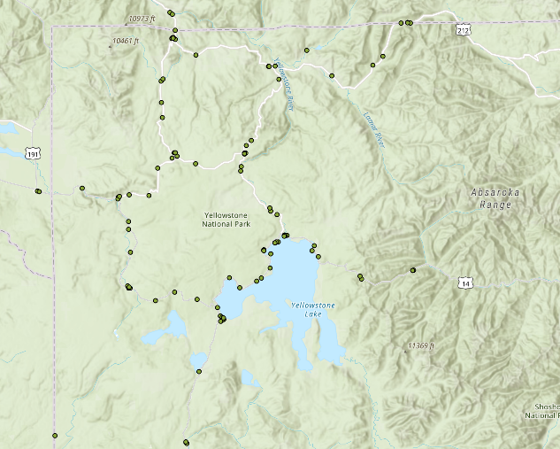

Fire Perimeter:

I left it as is since the polygon lined up with the YNP Boundary layers and were in the same area I expected them to be in.

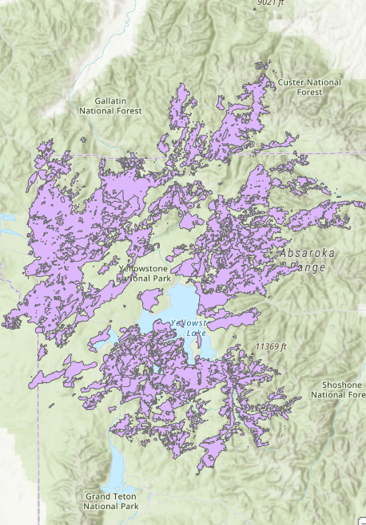

DEM:

I used the extract mask and hillshade geoprocessing tools to essentially clip and find the relief inside of the park boundary. Then I set the transparency to 50% and changed the color scheme.

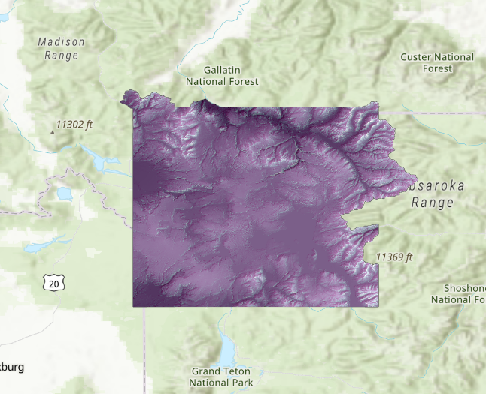

Question: How many of the Yellowstone Park facilities are in close proximity to locations where fires have started? I think to answer this question, we would have to determine what “close proximity” means. Once we have that figured out, we could use the buffer tool to draw the perimeter of our proximity and use summarize within to select all of the fire start locations within that buffer. When those points are selected, we could convert them into a feature class and then use the attribute table to count how many fire start points are within a close proximity to park facilities.